

|  |
| --- |
| Relabel |
| Software Engineering B.Sc.  Software Design Document |
|  |
| Authors**:**  Stav Blyman 305174377  Niv Braz 200864403 |
| **‏‏08/06/2017** |

Content

**1.** **Introductions** 3

**a.** **Overview** 3

**b.** **Functional Requirements** 3

**2.** **System Architecture** 4

**a.** **aaa** 4

**b.** **Usages** 5

c. **Technologies Review** 6

**d.** **Track Repository Scheme** 6

1. **Introductions**
   1. **Overview**

Relabel is a platform aimed for DJs to explore Trance music based by their own taste, and make it easy for them to instantly listen, like & add tracks into your individual playlists and more.

* 1. **Functional Requirements**
     + - * Make DJs profile while gathering information about the user’s favorite styles.
         * Propose music tracks base on the user’s profile and preferences.
         * Give the user an option to build playlists, sets, and save it.
         * Helping the user explore different Trance genres and allowing him to know new artists & tracks.
         * Music Player – allow to jump between tracks in the save playlist.

1. **System Architecture**
   1. **Data**

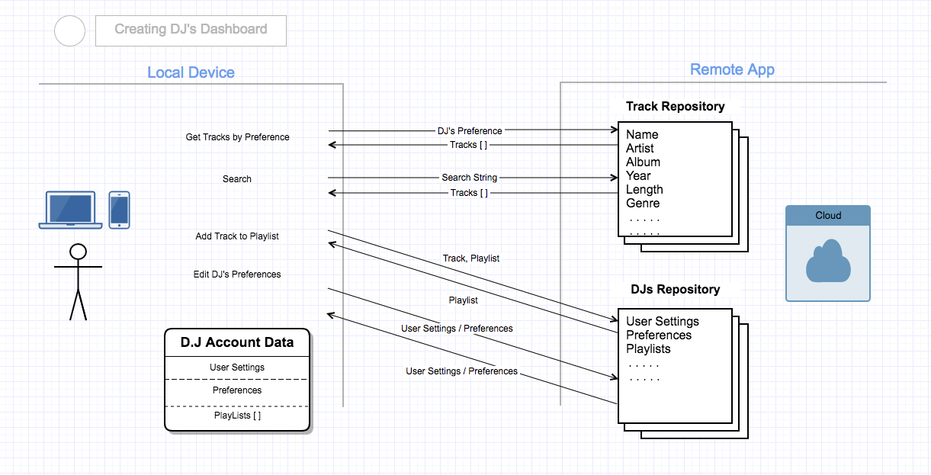

* 1. **Usages**

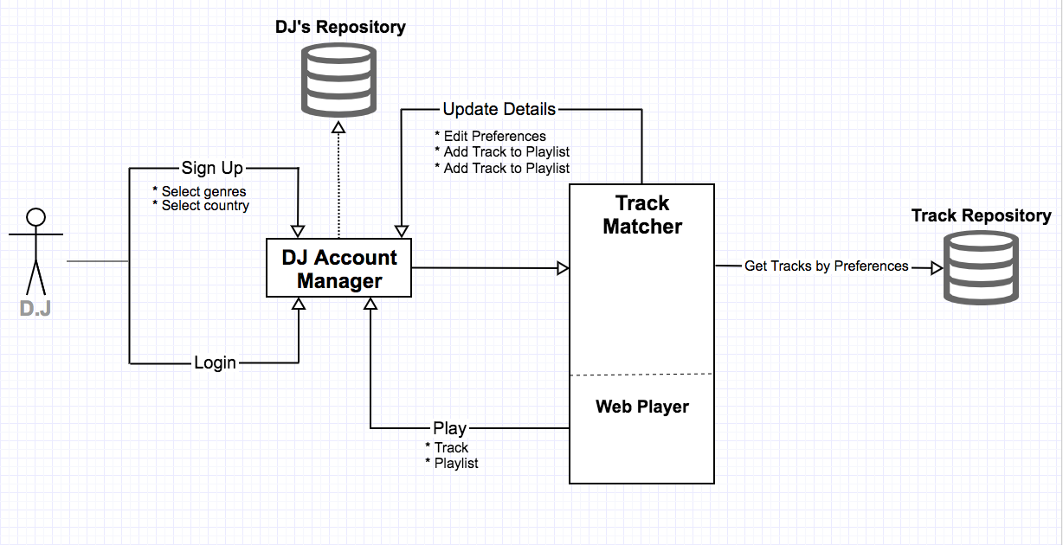

* 1. 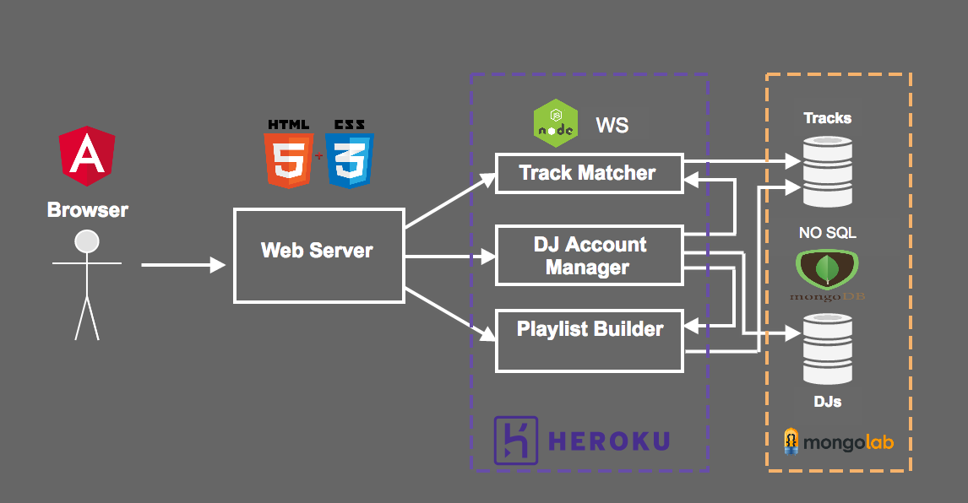**Technologies Review**
  2. **Track Repository Scheme**

